Developments on the population projection model used for Alaskan groundfish

Alaska Fisheries Science Center
Seattle WA 98115

Introduction
During the November 2004 groundfish Plan Team meetings the Teams requested that work on enhancing the standardized projection model (SPM) methodology. The current projection model and methods have been used since 1999 and were designed to provide the needed projection scenarios for the annual Environmental Assessment (EA) for the TAC specifications. Additionally, two other scenarios were conducted to determine whether a stock is currently in an overfished condition or is approaching an overfished condition. The details for the projection scenarios are given in Fig. 1.
The current methodology is problematic for a number of reasons. First, the model software was not designed to provide the basis for ABC and OFL recommendations beyond the coming year. Under amendment 48/48, and as was done in 2004, the Council is required to make ABC, TAC, and OFL recommendations for the next two years (i.e., for 2005 and 2006). The projection model and software was modified to accommodate this. Also, there were a number of assumptions in the projection model that required more careful evaluation (e.g., the underlying stock-recruitment relationship assumptions, and the estimated uncertainty in current stock abundance levels). In the section below titled “standardized projection model” the developments of the SPM are provided to show compatibility with all types of assessment models used for N. Pacific groundfish.
For the Programmatic Supplemental Environmental Impact Statement (PSEIS) an extension of the first version of SPM was developed (in 2002?). This involved linking the stock assessment information with observed species compositions by fishery. The resulting multi-species technical interaction model (MSTIM) allowed for evaluation of alternative approaches to groundfish fishery management for federally managed waters in Alaskan waters. The MSTIM provides more realistic catch-levels to be fed into single-species stock projections. Previously, single-species evaluations were typically done in isolation to issues such as regulatory limits on the overall catch level, bycatch constraints, and effort development plans. The data requirements for MSPTIM are extensive and if one goal is to provide a simple approach for providing catch-feedback as a function of ABC levels, development of a simpler approach is warranted. In the section title “multi-species considerations” a simple model based on historical patterns of TACs, ABCs, and catches is proposed as an option for estimating future TAC levels given future ABCs.
The projection model developments relate to a number of ongoing research activities at the AFSC. For example, North Pacific groundfish Management Strategy Evaluation (MSE) studies can use the projection model to easily evaluate current practices. Also, the NMFS National Standard Guidelines (NSG) for management under the Magnuson-Stevens Fisheries Management Conservation Act are currently under revision. The projection model and code has been designed to easily be adopted to meet anticipated future demands.

Standard projection model

Stock-recruitment relationship specifications
From the Ad-hoc meeting on projection model approaches, the report notes:
“The group discussed options for improving the projection model assumption about recruitment (i.e., that it varies about the mean level estimated from 1978 to the most recent estimated). In particular, having recruitment that is affected by spawning stock biomass (SSB) levels was considered to be more realistic. Also, specifying some degree of autocorrelation in residuals was considered desirable.
The options for using an alternative stock-recruitment relationship in the projection model as a function of SSB were given as:
- assume B_{msy}=B_{35%} , and F_{msy} = F_{35%} and solve for the parameters
- assume F_{msy} = F_{35%} and estimate stock-recruitment parameters given stock-recruitment output from the assessment model
- simply estimate the stock-recruitment parameters from input stock-recruitment output from assessment model
- use estimates of stock-recruitment parameters from within the assessment model
- use prior distributions for stock-recruitment parameters (or F_{msy} and B_{msy} levels)…
The actual specification of the type of stock-recruitment curve will initially be either Ricker or B-Holt.
The group suggested that option 2) would be a good place to start. They noted that assessment authors will need to supply estimates of SSB to match the current estimates of recruitment for the projection model.
Adding autocorrelation to future recruitment is considered important, especially given medium-term patterns in environmental variability that apparently affect recruitment. The specification for autocorrelation function will need to ensure that the expected values are correct.”
An option for writing files with all the annual (simulated) output is now available so that different analyses can be undertaken (currently, the results are summarized internally). The standard projection model developed for the purposes of the Council and authors of the EA are not exclusive—individuals are encouraged to undertake their own projection analyses as time permits. The SPM is intended to provide a tool for the Council and assessment models to have a common utility from which to project ABC and OFL levels.

Input files
Previously, the standardized projection model evolved into a number of different versions to accommodate models with sex-specific natural mortality, growth, and multiple fisheries. Also, the ability to specify future catch scenarios was added along with the standard EA alternatives. The revised version developed here has the flexibility to deal with all options in a simple way. Additionally, the features required by the NPFMC and NMFS to easily specify updated catch levels was added, as was the ability to run any number of species from within the same framework. To simplify this and minimize inadvertent edits, the input files were split into three separate files (Fig. 2). These are organized as follows:
- Master Setup file
  - Designed to control to assumptions and dimension of the projections, give a list of different scenarios (e.g., those listed in Fig. 3).
- The catch data file
  - Designed to specify the catch in each future year (for use by the Region and Council as values are updated) and points to the species-specific assessment result data file
- The species-specific assessment result data file
  - Contains species and model-run specific results from the assessment model
Actual working examples of these are provided at the following web page: www.afsc.noaa.gov/refm/stocks/projections.htm

Steps for doing projections
- Run the stock assessment model making note of the main demographic results, current numbers at age and historical stock-recruitment estimates
- Edit the stock-specific input files (e.g., the bottom panel of Fig 4).
- Edit the catch projections file which includes assumptions about future catch (e.g., the middle panel of Fig 5).
- Edit the “setup.dat” file which includes assumptions about projection specifications (e.g., stock-recruitment relationship or not, types of constraints, location and name of stock-specific detail files). This file is shown as the top panel of Fig 6.
- Run the projection model (e.g., use file “run.bat” by typing as follows: “run myfile” at the command line, where myfile is the root of the file name you selected (e.g., goa_pop)).
- Save and evaluate results (examine files in newly created myfile_out directory, these currently include the following:
bigfile.out full output file containing catch in every simulated year
bigsum.dat summarized version of bigfile.out
F_profile.out profile of main characteristics over fishing mortality
srec.out details on stock-recruitment data that were fit
means.out General projection results by species and alternatives
percentiles.out Gives percentiles of simulation results and variability
report.out Some simple summary output (e.g., mean age, generation time)
- Repeat steps 4)-6) as desired for different model configurations etc.
- Repeat steps 3)-7) as desired for different impacts of near-term catch levels
- Repeat steps 1)-8) as desired to evaluate different model results.

Example results
Since fitting a stock-recruitment relationship is one of the major enhancements for the SPM, the feature is highlighted here. In particular, varying assumptions about conditioning a stock-recruitment relationship is considered. It should be noted that the main purpose for including a stock-recruitment relationship is to provide more realistic assumptions about expected recruitment levels as stocks decline. This exercise should not be viewed as a rigorous assessment of stock productivity. However, stock-recruitment analyses are undeniably important for management considerations and the presentation here represents a limited evaluation of a large set of possible alternatives (e.g., low-frequency climate-driven changes in stock productivity).
Using the estimates of spawning biomass as reported in the 2004 SAFE reports, the fits for the conditioned (F_{msy} = F_{35%} ) and unconditioned (fit to stock-recruitment data only) between these options were reasonably consistent (Fig. 7). Examining yield for these cases shows that without the conditioning, some stocks have extremely high levels of F_{msy} and adding the conditions tends to reduce the level of F_{msy} (Fig. 8).
To understand the implications of using a stock-recruitment relationship in the projection model, it is useful to undertake some contrasts. For the first example, an “author’s recommended” ABC level was specified to be 40 times the current maximum permissible ABC level under Amendment 56 of the FMP. The intent here was to evaluate the performance of the stock to extreme levels of fishing mortality. However, since the other parts of the control-rule are implemented for the “Author’s recommended” option, the actual catch is high only in the first year since the spawning biomass is held to very low levels (and thus requiring large adjustments under the current control rule; Fig. 9.). Note that at very low levels the current practice of using the recent mean recruitment (and variability) results in a more optimistic outcome. To further evaluate the stock-recruitment influence on projections, a second set of runs was completed where the fishing mortality rate was unadjusted and simply held at a value of 1.0. For this scenario the stock completely collapsed in about 15 years when the stock-recruitment relationship was included but was held at about 2% of the current spawning biomass level under the mean-recruitment assumption (Fig. 10.).

Multi-species considerations
In this section a simple method for modeling TACs is demonstrated and applied using the new version of the SPM.

Data
As part of an effort to develop a standardized database for both archival and analytical purposes, information gleaned from SAFE reports, Federal Register notices, NPFMC documents, and NMFS Regional Office was obtained. Specifically, the TAC, ABC, and where possible, OFL levels were compiled by stocks and areas. Some discrepancies between reports were found and where these existed, the numbers in the Federal Register notice were given highest precedence. The initial layout of the database is shown in Table 1. This database allows for straightforward and flexible cross-tabulations (e.g., Table 2).
As a first step in evaluating historical patterns of TAC by species groups, a set of pair-wise plots were constructed. These show that EBS pollock TAC proportion was negatively correlated with flatfish species in addition to others while Pacific cod TAC proportion was largely independent of other TACs for both the full period of available data and for the data only since 1989 (Figs. 11 & 12). Since ABC levels are one of the main determinants of TACs by serving as an upper bound, the effect of ABCs are compared to each main species group. Pacific cod TAC levels are relatively independent of the other main species ABCs (except for Pacific cod ABC levels). An inverse relationship between pollock ABCs and flatfish TACs is apparent. Pollock TAC is affected most by pollock ABC up to the limit of about 75% of the overall TAC (2 million t).

A multispecies example of estimating TACs given ABCs
For illustration, an approach to estimate TAC levels by the main species groups was developed using a piecewise regression model fit to historical ABCs and TACs from 1989-2004 (Table 3). The formulation first required defining breakpoints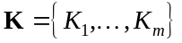where m is the number of segments for which a coefficient will be estimated. For each species, the ABCs were normalized to have a maximum of 1.0 over time and the values of the breakpoints were thus specified as equally spaced bins (i.e., 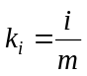). The TAC in year t for stock j can thus be given as:
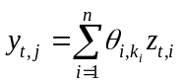
where
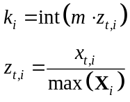
with 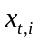equal to the ABC of the i^{th} stock in year t and is the parameter matrix of dimension to be estimated (n is the total number of stocks under consideration). This approach is somewhat simpler to applying a GAM (generalized additive model) to these data which were shown to outperform simple multiple regression approaches. Experimentation with different values of m suggested that little improvements were seen with m > 5. For the results presented here, a value of m=5 was used.
Moderate second-difference penalties were placed on the values of to ensure estimability for segments where data were scarce or non-existent (i.e., the values will tend towards a mean level). This approach resulted in reasonably good fits to the historical patterns (Fig. 13). For the projection model, the coefficients from the above regression were used along with an added constraint that in any future year t, 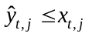 (i.e., the TAC for species j predicted from the above model must be less than or equal to the ABC in that year). The code for doing this estimation is provided in an Appendix.

Results of multispecies projections
As an example using the standard projection approach, 500 simulations were conducted for a 30 year period beginning in 2004. For each future year (beyond 2006) the catch was specified using the above algorithm. Mean values from these results are presented in Table 4. (NOTE, a table of the ABC and OFL levels are what would have been specified in each future year are also available, as are SSB and a (minimal) estimate on the distribution of catches (i.e., the actual uncertainty in future catches should be much higher). The mean trajectories of TACs show stabilization in trends in about 10-15 years (Fig. 14).

Summary
A number of changes to the SPM are completed. The ability to easily configure different catch scenarios for relevant stocks has been implemented through simple sets of data files (with further refinements expected). This should help facilitate the Council Plan Teams and the NMFS RO with the ABC and OFL levels they require for future years. Options to specify stock-recruitment relationships (primarily for more realistic projections) have been added. The code allows for technical interactions (in general) and an example using a simpler form than the “optimized” (LP) method used in the PSEIS was presented.
Future specifications will include autocorrelation in recruitment residuals. Additionally, the ability to simulate from estimates of current stock-size uncertainty is planned (and perhaps extended to apply to Alt 3b from the PSEIS). With minor modifications to the input files, trophic level output can easily be generated and is anticipated to be included in future versions. It is also envisioned that extensions to Tier 4 and lower species could be possible (as was done for the PSEIS).

References (to be revised)
Ackley, D. 1995. Bering Sea Fishery Simulation Model. Alaska Fishery Research Bulletin 2(1): 83-86.
Brown, B.E. , J.A. Brennan, and J.E. Palmer. 1979. Linear programming simulations of the effects of bycatch on the management of mixed species fisheries off the northeastern coast of the United States. Fishery Bulletin 76:851-860.
Larson, D .M., House, B. W. and Terry, J. M. 1996. Towards Efficient Bycatch management in Multispecies Fisheries: A Nonparametric Approach. Marine Resource Economics 11: 181-201.
Marasco, R.J. and Terry, J.M. 1982. Controlling Incidental Catch: An Economic Analysis of Six Management Options. Marine Policy 14:131-139.
Murawski, S.A., and Finn, J.T. 1986. Optimal effort allocation among competing mixed-species fisheries, subject to fishing mortality constraints. Canadian Journal of Fisheries and Aquatic Sciences 43:90-100.
Press, W.H., Teukolsky, S.A., Vetterling, W.T. and Flannerty, B.P. 1992. Numerical Recipes in C: The Art of Scientific Computing. 2nd Edition. Cambridge University Press. New York.

Figures

Standard Harvest Scenarios and Projection Methodology (assessment year=2004)
A standard set of projections is required for each stock managed under Tiers 1, 2, or 3, of Amendment 56. This set of projections encompasses seven harvest scenarios designed to satisfy the requirements of Amendment 56, the National Environmental Policy Act, and the Magnuson-Stevens Fishery Conservation and Management Act (MSFCMA).
For each scenario, the projections begin with the vector of 2004 numbers at age estimated in the assessment. This vector is then projected forward to the beginning of 2004 using the schedules of natural mortality and selectivity described in the assessment and the best available estimate of total (year-end) catch for 2004. In each subsequent year, the fishing mortality rate is prescribed on the basis of the spawning biomass in that year and the respective harvest scenario. In each year, recruitment is drawn from an inverse Gaussian distribution whose parameters consist of maximum likelihood estimates determined from recruitments estimated in the assessment. Spawning biomass is computed in each year based on the time of peak spawning and the maturity and weight schedules described in the assessment. Total catch is assumed to equal the catch associated with the respective harvest scenario in all years. This projection scheme is run 1000 times to obtain distributions of possible future stock sizes, fishing mortality rates, and catches.
Five of the seven standard scenarios will be used in an Environmental Assessment prepared in conjunction with the final SAFE. These five scenarios, which are designed to provide a range of harvest alternatives that are likely to bracket the final TAC for 2004, are as follow (A “max F_{ABC}” refers to the maximum permissible value of F_{ABC} under Amendment 56):
Scenario 1: In all future years, F is set equal to max F_{ABC}. (Rationale: Historically, TAC has been constrained by ABC, so this scenario provides a likely upper limit on future TACs.)
Scenario 2: In all future years, F is set equal to a constant fraction of max F_{ABC}, where this fraction is equal to the ratio of the F_{ABC} value for 2005 recommended in the assessment to the max F_{ABC} for 2005. (Rationale: When F_{ABC} is set at a value below max F_{ABC}, it is often set at the value recommended in the stock assessment.)
Scenario 3: In all future years, F is set equal to 50% of max F_{ABC}. (Rationale: This scenario provides a likely lower bound on F_{ABC} that still allows future harvest rates to be adjusted downward when stocks fall below reference levels.)
Scenario 4: In all future years, F is set equal to the 2000-2004 average F. (Rationale: For some stocks, TAC can be well below ABC, and recent average F may provide a better indicator of F_{TAC} than F_{ABC}.)
Scenario 5: In all future years, F is set equal to zero. (Rationale: In extreme cases, TAC may be set at a level close to zero.)
Two other scenarios are needed to satisfy the MSFCMA’s requirement to determine whether a stock is currently in an overfished condition or is approaching an overfished condition. These two scenarios are as follow (for Tier 3 stocks, the MSY level is defined as B_{35%}):
Scenario 6: In all future years, F is set equal to FOFL. (Rationale: This scenario determines whether a stock is overfished. If the stock is expected to be 1) above its MSY level in 2005 or 2) above ½ of its MSY level in 2005 and above its MSY level in 2015 under this scenario, then the stock is not overfished.)
Scenario 7: In 2005 and 2006, F is set equal to max F_{ABC}, and in all subsequent years, F is set equal to F_{OFL}. (Rationale: This scenario determines whether a stock is approaching an overfished condition. If the stock is expected to be above its MSY level in 2017 under this scenario, then the stock is not approaching an overfished condition.)

Figure 1. Standard harvest scenarios used for the projection model (e.g., for assessments done in 2004).
Master Setup file example
# Run nameRun1 # Number of Alternatives 5 # List of alternatives 1 # List of alternatives 2 # List of alternatives 3 # List of alternatives 4 # List of alternatives 5 # Flag to set TAC equal to ABC (1 means true, otherwise false) 1 # Stock-recruitment type (1=Ricker, 2=Bholt)1 # Recruitment projection (default: 1 = use observed mean and std, option 2 = use est. SRR and sigma R) 1 # Condition that Fmsy == F35%? (0 means no, non-zero means use condition (affects SRR fits) 0 # Condition that there is a prior that mean historical recruitment is similar to expected recruitment0 # Flag to write big file (of all simulations rather than a summary, 0 means don't bother) 1 # Number of projection years 14 # Number of simulations 50 # Begin Year 2004
Species specific file example
EBS_Pollock# Species name
1# SSL Species
0 # Constant buffer of Dorn
1 # Number of fisheries
1 # Number of sexes
0.178881 # average 5yr Fishing mortality
1 # Author F multiplier
0.4 # ABC SPR
0.35 # MSY SPR
4 # Month of spawning
15 # Number of ages
1 # Fratio
# Natural mortality at age: 0.9 0.45 0.3 0.3 …
# Maturity at age:0 0.008 0.289 0.641 0.842…
# Avg wt of female spawning:0.0066 0.17 0.384205 0.503487…
# Wt fsh 0.0066 0.17 0.384205 0.503487…
# selectivity Fishery 10.00167197 0.0201642 0.171093 0.462636…
# natage 13532 4513.93 2970.19 7060.6
# Nrec 27
# rec 28254.9 64058.7 26341.3 30002
# SSB21312 23367l …
…
Spp_Catch file example
Number_of_years with specified catch:3
Number of species 7
Data files for each species
goa_wp.dat GOA_pcod.dat GOA_sable.dat GOA_atf.dat GOA_fhs.dat GOA_pop.dat GOA_nrthrns.dat
ABC Multipliers
1111111
Scalars (for population level)
111.3157891000100010001000
Number of TAC model categories
7
TAC model indices (for aggregating)
1234567
Catch in each future year
20047258.619.77368233162747118005000
200585.37654.03320.9736826753.673004.667119435091
200698.00451.53719.60526267543226118094700

Figure 2. General layout of projection model input files.

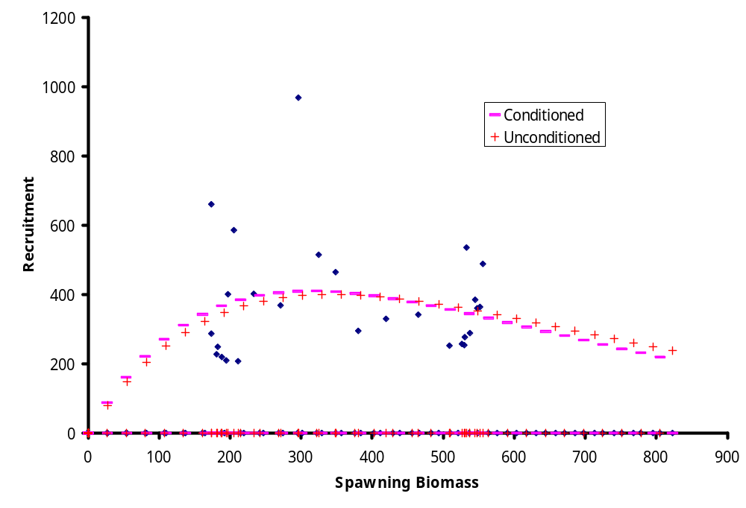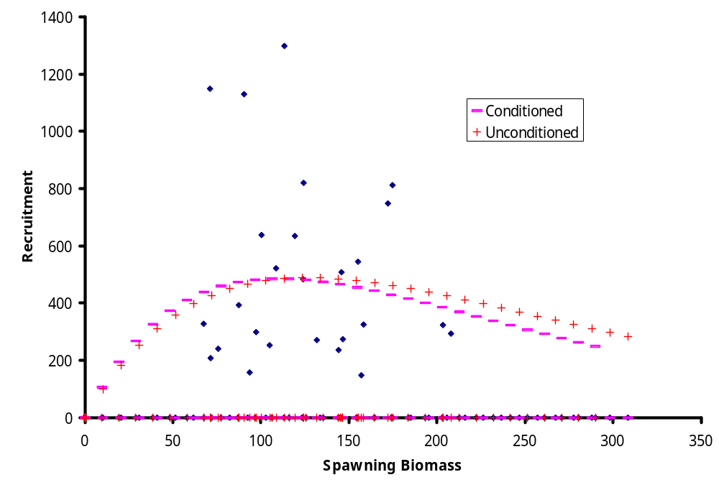

Figure 3. Fit of stock-recruitment relationship with and without added condition that F_{msy} = F_{35%} .
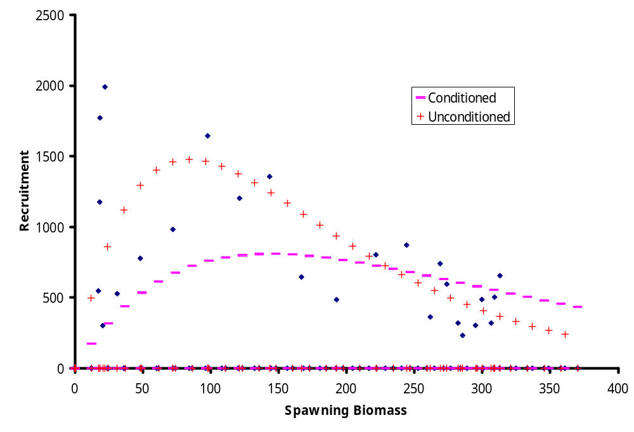
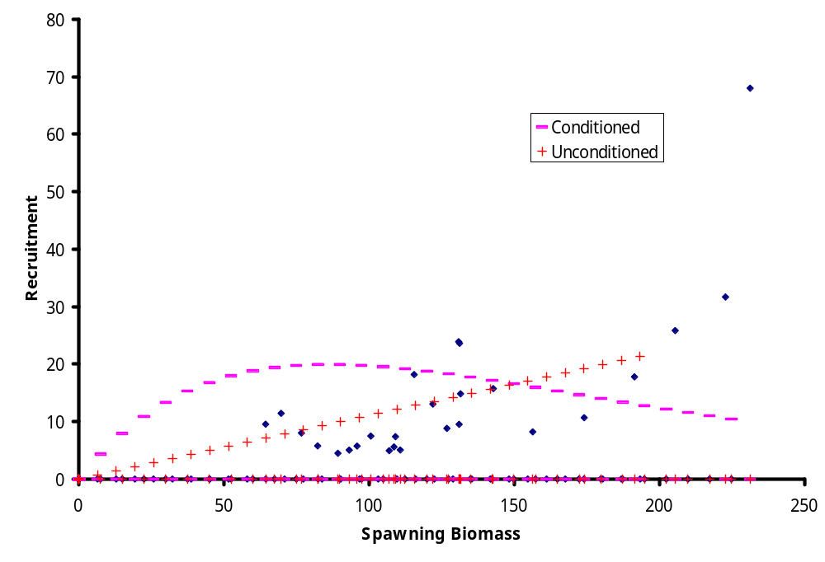

Figure 4. Continued.
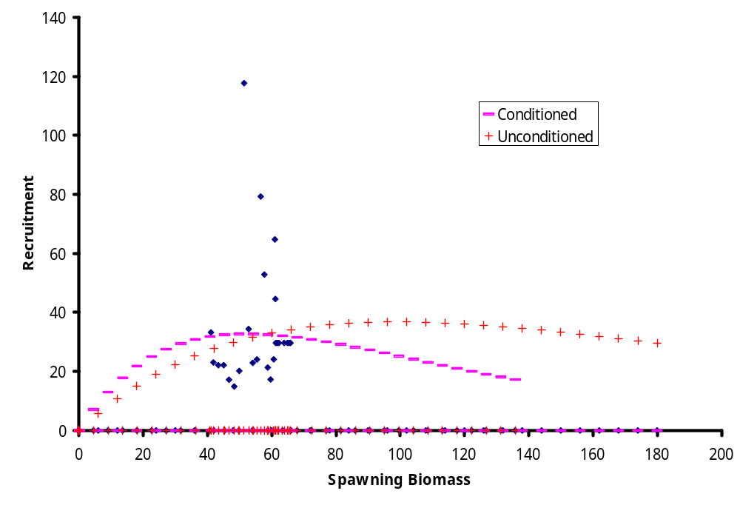
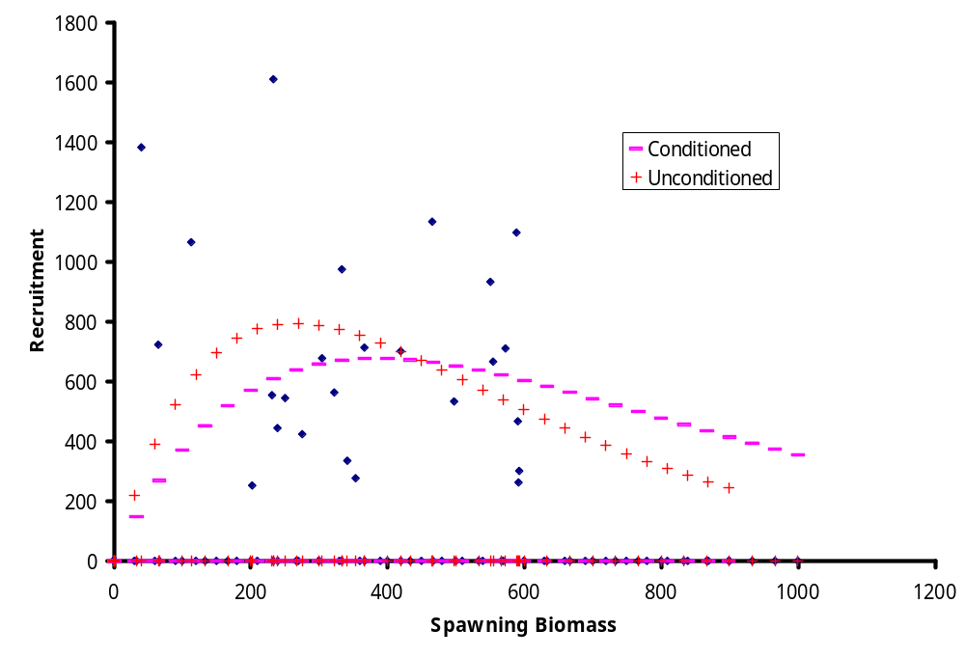

Figure 5. Continued.
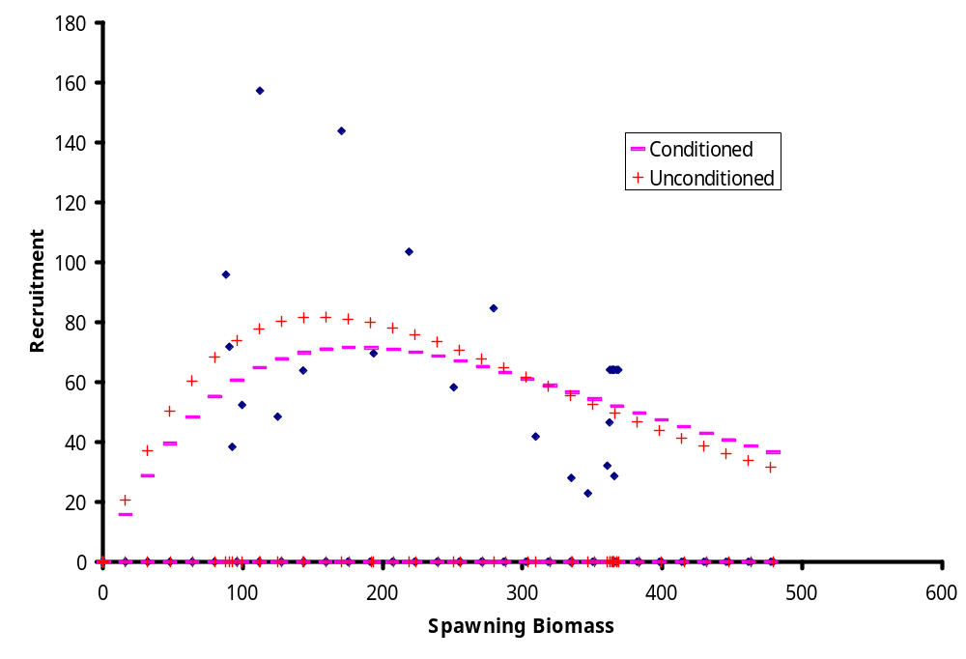
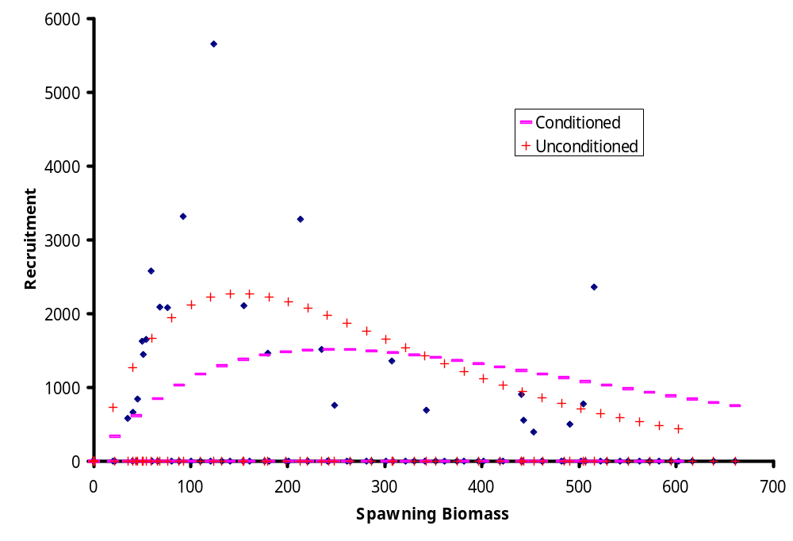

Figure 6. Continued.
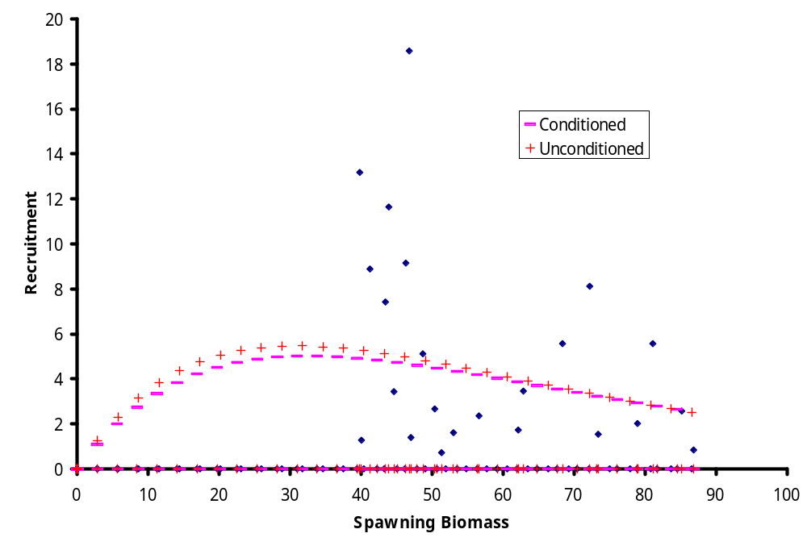
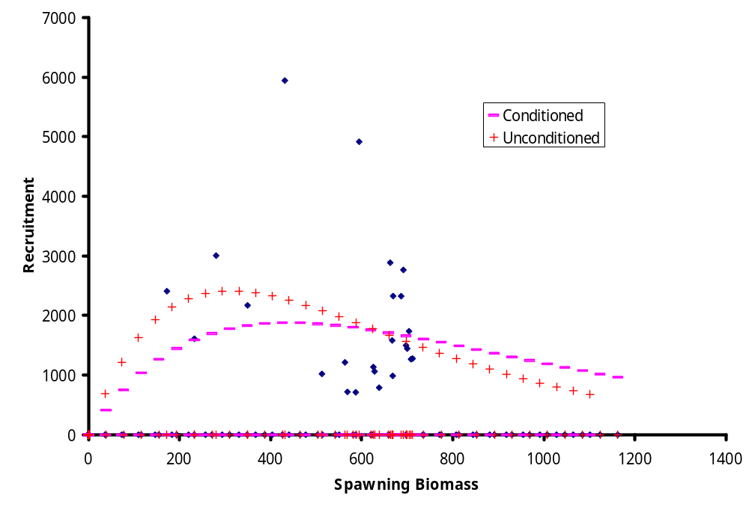

Figure 7. Continued.
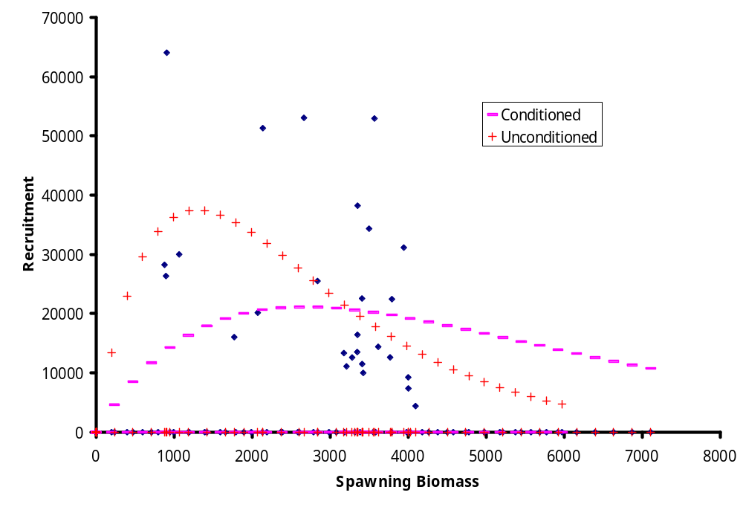

Figure 8. Continued.
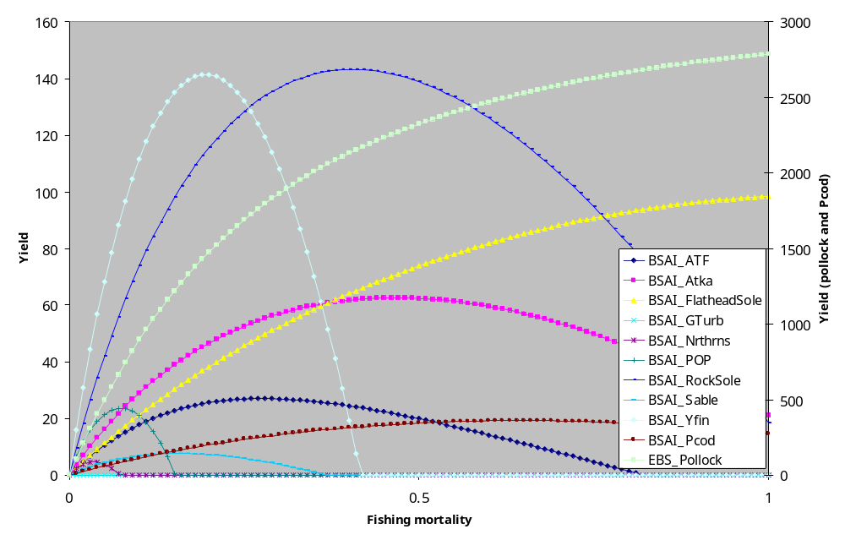
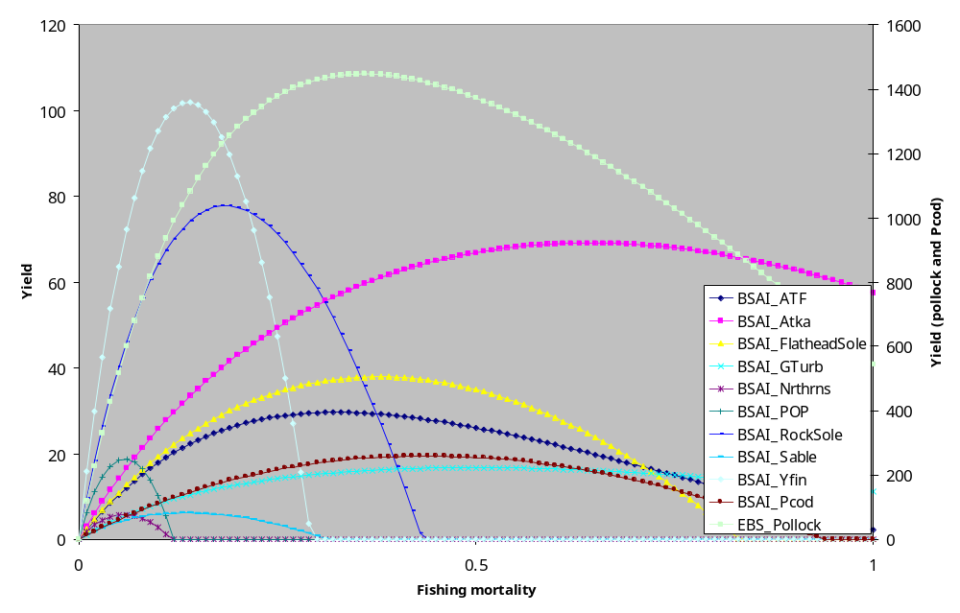

Figure 9. Equilibrium yield profiles over fishing mortality rates for unconditioned cases (stock-recruitment relationships fit only to output from stock assessments, top panel) and conditioned cases (where F_{msy} = F_{35%} , bottom panel).
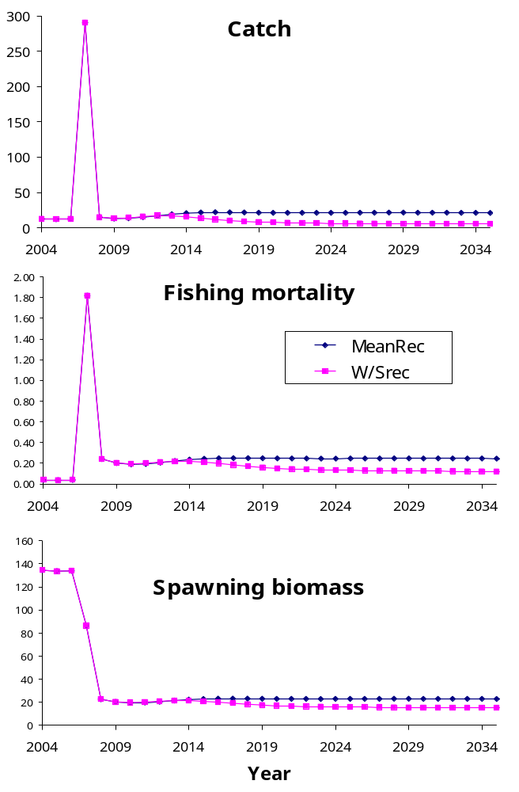

Figure 10. Mean trajectories for scenarios where the status-quo situation ABC multiplier is very large. This contrasts the behavior of the assumption about using mean recruitment (current projection system) versus a conditioned (F_{msy} = F_{35%}) assumption..

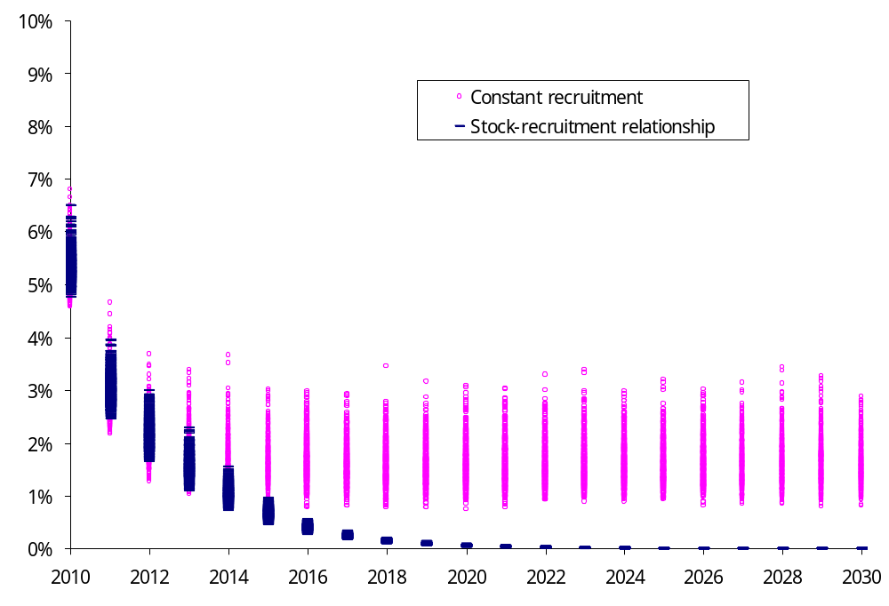

Figure 11. Projections of spawning stock biomass (as a percentage of the 2004 level) for Pacific ocean perch in the Bering Sea/Aleutian Islands region under extreme constant levels of fishing mortality (F = 1.0). The projections represented by the circles are based on the assumption that recruitment will vary and have the same mean as in the recent path whereas the solid dashes are based on the assumption that a stock-recruitment relationship (i.e., conditioned such that the F_{35%} = F_{msy} ).
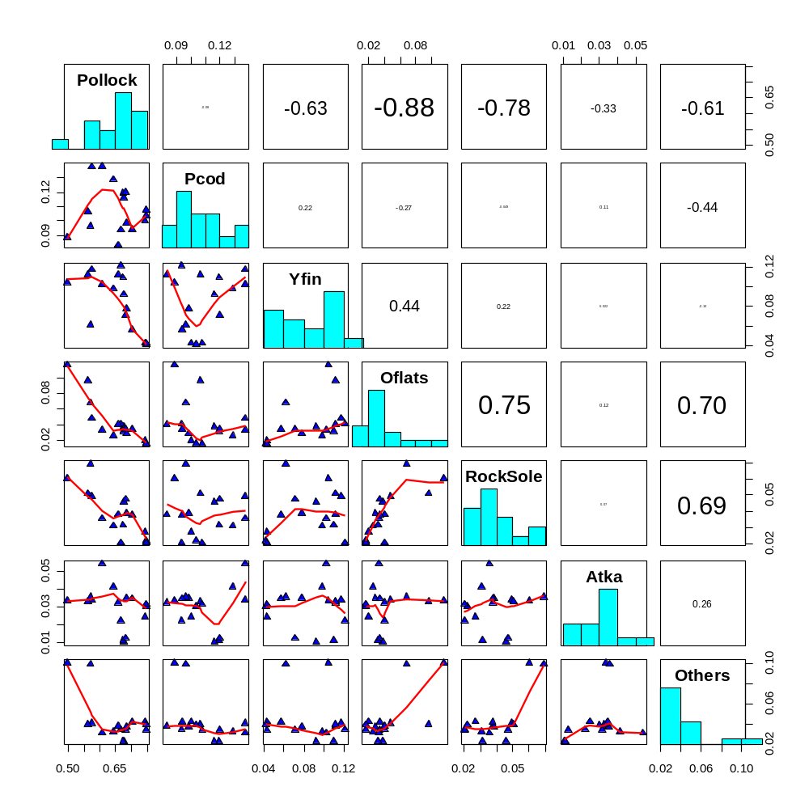

Figure 12. Correlations of TAC proportions among main species groups for the BSAI during 1989-2004. Values in boxes on upper right side represent correlations.
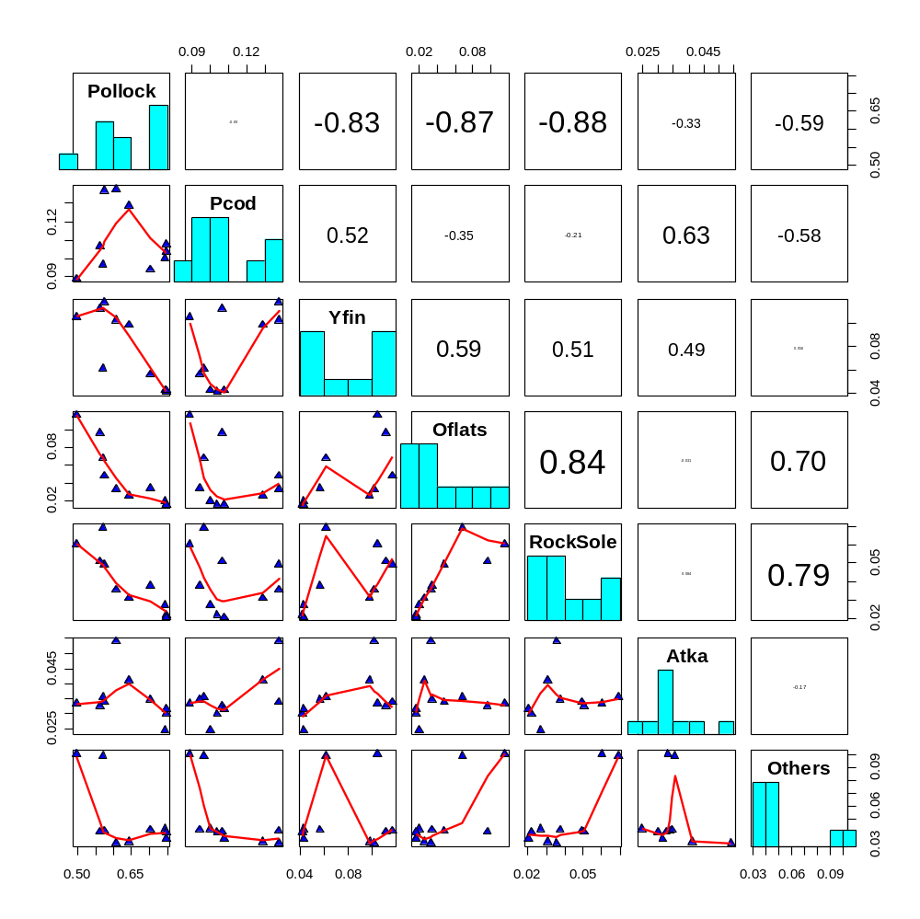

Figure 13. Correlations of TAC proportions among main species groups for the BSAI during 1995-2004. Values in boxes on upper right side represent correlations.

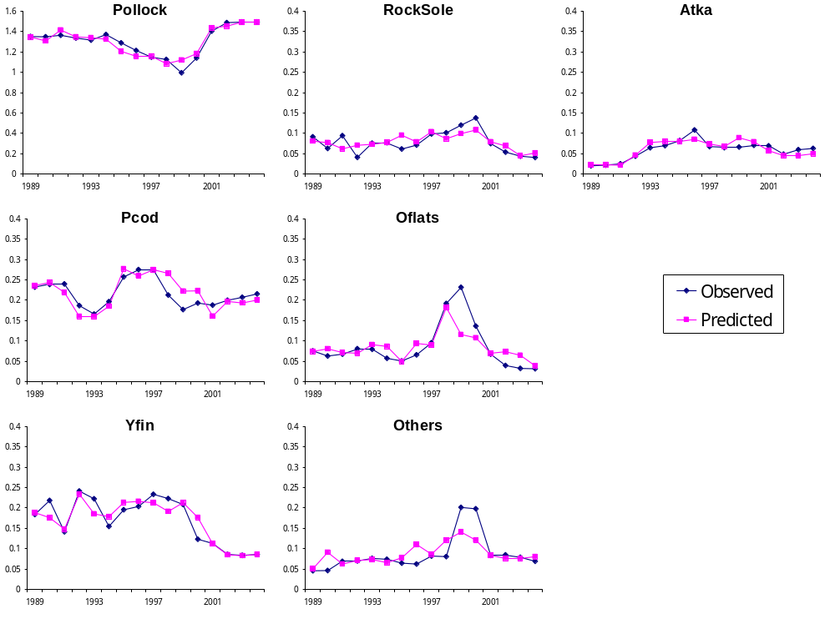

Figure 14. Observed versus predicted TAC levels given historical data presented in Table 1 (millions of tons).

Pollock and Pacific cod (projected TACs in metric tons)
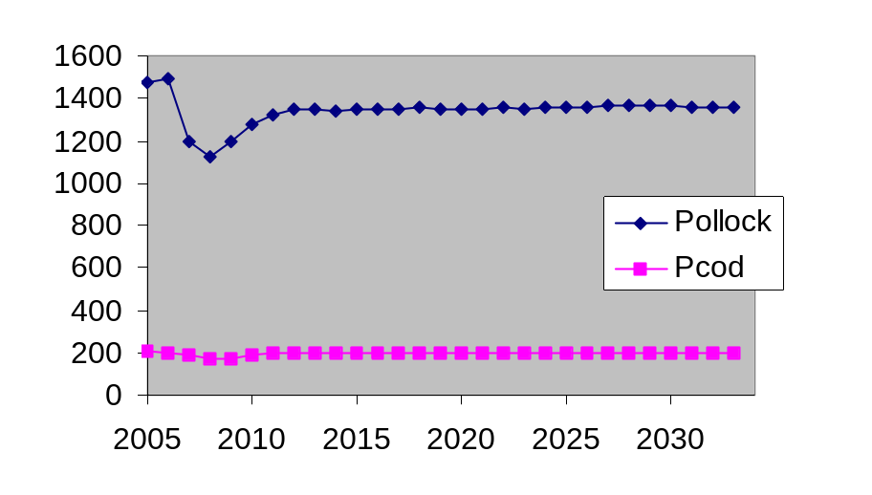
Other species (projected TACs in metric tons)
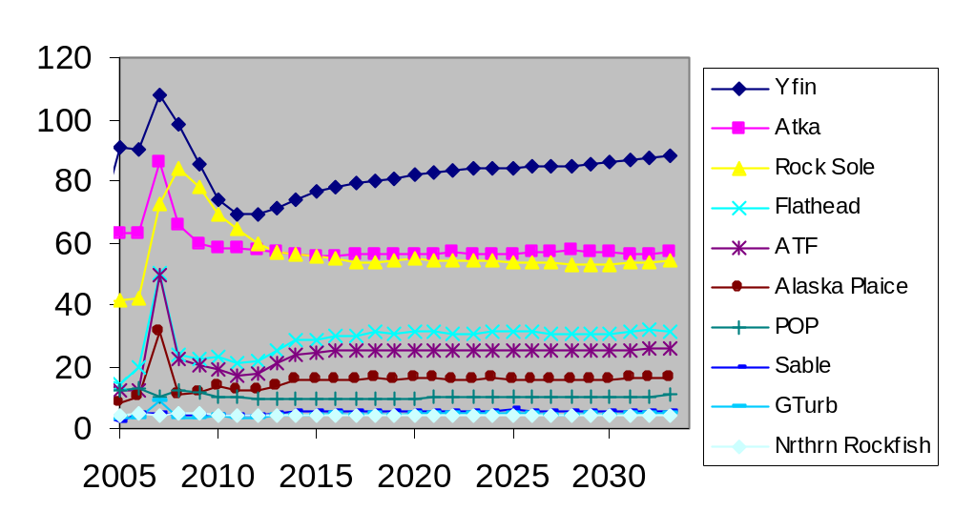

Figure 15. Example 30-year multi-species projections of BSAI mean TACs using the regression model of historical TAC levels given ABC values.

Tables

Table 1. Initial database layout (subject to validation and further edits) for historical ABC and TAC levels as available at www.afsc.noaa.gov/refm/stocks/projections.htm.
Source | Area | Mgt_Area | Name_Quant | Spp | Year | Level | Reclass
SAFE_2004 | BSAI | BSAI | TAC | Atka | 1978 | 24,800 | Atka
SAFE_2004 | BSAI | BSAI | TAC | Atka | 1979 | 24,800 | Atka
SAFE_2004 | BSAI | BSAI | TAC | Atka | 1980 | 24,800 | Atka
…

Table 2. Example cross tabulations from the database (subject to validation and further edits). ABC (top table) and TAC (lower table) levels for BSAI regions.
 | BSAI ABC
Year | Atka | Oflats | OthSpp | Pcod | Pollock | POP | RockFish | RockSole | Sable | Gturb | YfinSole | FheadSole | Arrowtooth | AKPlaice | NrthrnRF | Grand Total
1977 |  | 65,000 |  |  | 950,000 | 21,500 |  |  | 7,400 | 40,000 | 106,000 |  |  |  |  | 1,189,900
1978 |  | 139,000 |  |  | 950,000 | 21,500 |  |  | 6,500 | 40,000 | 106,000 |  |  |  |  | 1,263,000
1979 |  | 61,000 |  |  | 1,100,000 | 21,500 | 7,700 |  | 5,000 | 90,000 | 117,000 |  |  |  |  | 1,402,200
1980 | 24,800 | 61,000 | 74,200 | 148,000 | 1,300,000 | 18,000 | 7,700 |  | 3,700 | 76,000 | 169,000 |  | 20,000 |  |  | 1,902,400
1981 | 24,800 | 92,500 | 94,400 | 160,000 | 1,300,000 | 18,000 | 21,300 |  | 3,700 | 59,800 | 214,500 |  | 16,500 |  |  | 2,005,500
1982 | 24,800 | 92,500 | 94,300 | 168,000 | 1,300,000 | 18,000 | 22,000 |  | 2,900 | 60,000 | 214,500 |  | 16,500 |  |  | 2,013,500
1983 | 25,500 | 119,200 | 61,400 | 298,200 | 1,300,000 | 11,800 | 14,100 |  | 2,900 | 65,000 | 214,500 |  | 20,000 |  |  | 2,132,600
1984 | 25,500 | 150,200 | 61,000 | 291,300 | 1,300,000 | 12,160 | 14,100 |  | 6,185 | 47,500 | 310,000 |  | 20,000 |  |  | 2,237,945
1985 | 37,700 | 150,200 | 51,200 | 347,400 | 1,300,000 | 12,760 | 8,910 |  | 6,080 | 44,200 | 310,000 |  | 20,000 |  |  | 2,288,450
1986 | 30,800 | 137,500 | 35,900 | 249,300 | 1,300,000 | 10,200 | 8,900 |  | 7,200 | 35,000 | 230,000 |  | 20,000 |  |  | 2,064,800
1987 | 30,800 | 193,300 | 49,500 | 400,000 | 1,300,000 | 14,700 | 1,880 |  | 7,700 | 20,000 | 187,000 |  | 30,900 |  |  | 2,235,780
1988 | 21,000 | 331,900 | 54,000 | 385,300 | 1,500,000 | 22,600 | 1,500 |  | 9,200 | 14,100 | 254,000 |  | 99,500 |  |  | 2,693,100
1989 | 21,000 | 155,900 | 59,000 | 370,600 | 1,340,000 | 22,600 | 1,500 | 171,000 | 6,200 | 20,300 | 241,000 |  | 163,700 |  |  | 2,572,800
1990 | 24,000 | 188,000 | 55,500 | 417,000 | 1,450,000 | 22,900 | 1,600 | 216,300 | 2,700 | 7,000 | 278,900 |  | 106,500 |  |  | 2,770,400
1991 | 24,000 | 219,700 | 28,700 | 229,000 | 1,676,000 | 15,345 | 1,325 | 246,500 | 3,100 | 7,000 | 250,600 |  | 116,400 |  |  | 2,817,670
1992 | 43,000 | 199,600 | 27,200 | 182,000 | 1,490,000 | 15,240 | 1,325 | 260,800 | 1,400 | 7,000 | 372,000 |  | 82,300 |  |  | 2,681,865
1993 | 117,100 | 191,000 | 26,600 | 164,500 | 1,340,000 | 17,230 | 1,325 | 185,000 | 1,500 | 7,000 | 238,000 |  | 72,000 |  |  | 2,361,255
1994 | 122,500 | 225,000 | 27,500 | 191,000 | 1,330,000 | 14,210 | 1,135 | 313,000 | 540 | 17,200 | 230,000 |  | 93,400 |  |  | 2,565,485
1995 | 125,000 | 117,000 | 27,600 | 328,000 | 1,250,000 | 13,750 | 1,135 | 347,000 | 1,600 | 7,000 | 277,000 | 138,000 | 113,000 |  |  | 2,746,085
1996 | 116,000 | 102,000 | 27,600 | 305,000 | 1,190,000 | 22,360 | 1,449 | 361,000 | 2,500 | 10,300 | 278,000 | 116,000 | 129,000 |  |  | 2,661,209
1997 | 66,700 | 97,500 | 25,800 | 306,000 | 1,130,000 | 21,948 | 1,087 | 296,000 | 2,675 | 12,350 | 233,000 | 101,000 | 108,000 |  |  | 2,402,060
1998 | 64,300 | 164,000 | 25,800 | 210,000 | 1,110,000 | 18,962 | 1,054 | 312,000 | 2,680 | 15,000 | 220,000 | 132,000 | 147,000 |  |  | 2,422,796
1999 | 73,300 | 154,000 | 32,860 | 177,000 | 992,000 | 20,862 | 1,054 | 309,000 | 3,200 | 14,200 | 212,000 | 77,300 | 140,000 |  |  | 2,206,776
2000 | 70,800 | 117,000 | 31,360 | 193,000 | 1,139,000 | 21,129 | 1,054 | 230,000 | 3,900 | 9,300 | 191,000 | 73,500 | 131,000 |  |  | 2,212,043
2001 | 69,300 | 122,000 | 35,570 | 188,000 | 1,874,270 | 11,930 | 8,829 | 228,000 | 4,060 | 8,400 | 176,000 | 84,000 | 117,000 |  |  | 2,927,359
2002 | 49,000 | 18,100 | 41,070 | 223,000 | 2,138,110 | 14,800 | 2,065 | 225,000 | 4,480 | 8,100 | 115,000 | 82,600 | 113,000 | 143,000 | 6,760 | 3,184,085
2003 | 63,000 | 16,000 | 45,270 | 223,000 | 2,373,470 | 15,100 | 2,561 | 110,000 | 6,000 | 5,880 | 114,000 | 66,000 | 112,000 | 137,000 | 7,101 | 3,296,382
2004 | 66,700 | 13,500 | 48,780 | 223,000 | 2,601,970 | 13,300 | 2,315 | 139,000 | 6,450 | 4,740 | 114,000 | 61,900 | 115,000 | 203,000 | 6,880 | 3,620,535

 | BSAI TAC
Year | Atka | Oflats | OthSpp | Pcod | Pollock | POP | RockFish | RockSole | Sable | Gturb | YfinSole | FheadSole | Arrowtooth | AKPlaice | NrthrnRF | Grand Total
1977 |  | 100,000 | 103,600 | 58,000 | 950,000 | 21,500 |  |  | 7,400 |  | 106,000 |  |  |  |  | 1,346,500
1978 | 24,800 | 159,000 | 111,400 | 70,500 | 950,000 | 21,500 |  |  | 4,500 |  | 126,000 |  |  |  |  | 1,467,700
1979 | 24,800 | 139,000 | 103,600 | 58,000 | 950,000 | 21,500 |  |  | 4,500 |  | 106,000 |  |  |  |  | 1,407,400
1980 | 24,800 | 61,000 | 84,249 | 70,700 | 1,000,000 | 10,750 | 7,727 |  | 5,000 |  | 117,000 |  |  |  |  | 1,381,226
1981 | 24,800 | 61,000 | 84,249 | 78,700 | 1,000,000 | 10,750 | 7,727 |  | 5,000 |  | 117,000 |  |  |  |  | 1,389,226
1982 | 24,800 | 61,000 | 84,249 | 78,700 | 1,000,000 | 10,750 | 7,727 |  | 5,000 |  | 117,000 |  |  |  |  | 1,389,226
1983 | 24,800 | 61,000 | 87,314 | 120,000 | 1,000,000 | 10,750 | 7,727 |  | 5,000 |  | 117,000 |  |  |  |  | 1,433,591
1984 | 35,000 | 111,490 | 48,900 | 210,000 | 1,200,000 | 6,360 | 7,050 |  | 5,340 |  | 230,000 |  |  |  |  | 1,854,140
1985 | 37,700 | 111,400 | 47,980 | 220,000 | 1,200,000 | 4,800 | 6,620 |  | 4,500 |  | 229,900 |  |  |  |  | 1,862,900
1986 | 30,800 | 124,200 | 32,800 | 229,000 | 1,200,000 | 7,625 | 6,625 |  | 6,450 | 33,000 | 209,500 |  | 20,000 |  |  | 1,900,000
1987 | 30,800 | 148,300 | 15,500 | 280,000 | 1,200,000 | 11,025 | 1,880 |  | 7,700 | 20,000 | 187,000 |  | 9,795 |  |  | 1,912,000
1988 | 21,000 | 131,369 | 11,000 | 200,000 | 1,300,000 | 11,000 | 1,500 |  | 8,400 | 11,200 | 254,000 |  | 5,531 |  |  | 1,955,000
1989 | 20,285 | 75,183 | 14,264 | 230,681 | 1,340,000 | 11,000 | 1,500 | 90,763 | 6,200 | 6,800 | 182,675 |  | 6,000 |  |  | 1,985,351
1990 | 21,000 | 60,150 | 5,500 | 227,000 | 1,280,000 | 12,900 | 1,600 | 60,000 | 7,200 | 7,000 | 207,650 |  | 10,000 |  |  | 1,900,000
1991 | 24,000 | 64,675 | 16,000 | 229,000 | 1,300,000 | 15,345 | 1,325 | 90,000 | 6,300 | 7,000 | 135,000 |  | 20,000 |  |  | 1,908,645
1992 | 43,000 | 79,000 | 22,000 | 182,000 | 1,300,000 | 16,640 | 8,215 | 40,000 | 4,400 | 7,000 | 235,000 |  | 10,000 |  |  | 1,947,255
1993 | 64,000 | 79,000 | 28,600 | 164,500 | 1,300,000 | 18,430 | 7,390 | 75,000 | 4,100 | 7,000 | 220,000 |  | 10,000 |  |  | 1,978,020
1994 | 68,000 | 56,000 | 29,500 | 191,000 | 1,330,000 | 14,210 | 8,025 | 75,000 | 3,340 | 7,000 | 150,325 |  | 10,000 |  |  | 1,942,400
1995 | 80,000 | 19,540 | 21,000 | 250,000 | 1,250,000 | 13,610 | 7,223 | 60,000 | 3,800 | 7,000 | 190,000 | 30,000 | 10,227 |  |  | 1,942,400
1996 | 106,157 | 35,000 | 20,125 | 270,000 | 1,190,000 | 21,514 | 1,304 | 70,000 | 2,300 | 7,000 | 200,000 | 30,000 | 9,000 |  |  | 1,962,400
1997 | 66,700 | 50,750 | 25,800 | 270,000 | 1,130,000 | 21,948 | 1,087 | 97,185 | 2,300 | 9,000 | 230,000 | 43,500 | 20,760 |  |  | 1,969,030
1998 | 64,300 | 89,434 | 25,800 | 210,000 | 1,110,000 | 18,962 | 1,054 | 100,000 | 2,680 | 15,000 | 220,000 | 100,000 | 16,000 |  |  | 1,973,230
1999 | 66,400 | 154,000 | 32,860 | 177,000 | 992,000 | 20,362 | 1,054 | 120,000 | 3,200 | 9,000 | 207,980 | 77,300 | 134,354 |  |  | 1,995,510
2000 | 70,800 | 83,813 | 31,360 | 193,000 | 1,139,000 | 21,129 | 1,054 | 137,760 | 3,900 | 9,300 | 123,262 | 52,652 | 131,000 |  |  | 1,998,030
2001 | 69,300 | 28,000 | 28,470 | 188,000 | 1,403,000 | 11,930 | 8,829 | 75,000 | 4,060 | 8,400 | 113,000 | 40,000 | 22,011 |  |  | 2,000,000
2002 | 49,000 | 3,000 | 32,795 | 200,000 | 1,486,100 | 14,800 | 2,065 | 54,000 | 4,480 | 8,000 | 86,000 | 25,000 | 16,000 | 12,000 | 6,760 | 2,000,000
2003 | 60,000 | 3,000 | 34,279 | 207,500 | 1,492,810 | 14,100 | 2,561 | 44,000 | 6,000 | 4,000 | 83,750 | 20,000 | 12,000 | 10,000 | 6,000 | 2,000,000
2004 | 63,000 | 3,000 | 28,480 | 215,500 | 1,493,050 | 12,580 | 1,815 | 41,000 | 6,000 | 3,500 | 86,075 | 19,000 | 12,000 | 10,000 | 5,000 | 2,000,000

Table 3. Historical specifications of ABC levels (top) and TAC levels (bottom panel) for BSAI groundfish species.
ABC | Stock (millions of tons)
Yr | Pollock | Pcod | Yfin | RockSole | Oflats | Others | Atka
1989 | 1.340 | 0.371 | 0.241 | 0.171 | 0.156 | 0.273 | 0.021
1990 | 1.450 | 0.417 | 0.279 | 0.216 | 0.188 | 0.196 | 0.024
1991 | 1.676 | 0.229 | 0.251 | 0.247 | 0.220 | 0.172 | 0.024
1992 | 1.490 | 0.182 | 0.372 | 0.261 | 0.200 | 0.134 | 0.043
1993 | 1.340 | 0.165 | 0.238 | 0.185 | 0.191 | 0.126 | 0.117
1994 | 1.330 | 0.191 | 0.230 | 0.313 | 0.225 | 0.154 | 0.123
1995 | 1.250 | 0.328 | 0.277 | 0.347 | 0.255 | 0.164 | 0.125
1996 | 1.190 | 0.305 | 0.278 | 0.361 | 0.218 | 0.193 | 0.116
1997 | 1.130 | 0.306 | 0.233 | 0.296 | 0.199 | 0.172 | 0.067
1998 | 1.110 | 0.210 | 0.220 | 0.312 | 0.296 | 0.210 | 0.064
1999 | 0.992 | 0.177 | 0.212 | 0.309 | 0.231 | 0.212 | 0.073
2000 | 1.139 | 0.193 | 0.191 | 0.230 | 0.191 | 0.198 | 0.071
2001 | 1.874 | 0.188 | 0.176 | 0.228 | 0.206 | 0.186 | 0.069
2002 | 2.138 | 0.223 | 0.115 | 0.225 | 0.244 | 0.190 | 0.049
2003 | 2.373 | 0.223 | 0.114 | 0.110 | 0.219 | 0.194 | 0.063
2004 | 2.602 | 0.223 | 0.114 | 0.139 | 0.278 | 0.197 | 0.067
TAC | Stock (percentage of 2-million ton TAC)
Yr | Pollock | Pcod | Yfin | RockSole | Oflats | Others | Atka
1989 | 67.5% | 11.6% | 9.2% | 4.6% | 3.8% | 2.3% | 1.0%
1990 | 67.4% | 11.9% | 10.9% | 3.2% | 3.2% | 2.3% | 1.1%
1991 | 68.1% | 12.0% | 7.1% | 4.7% | 3.4% | 3.5% | 1.3%
1992 | 66.8% | 9.3% | 12.1% | 2.1% | 4.1% | 3.5% | 2.2%
1993 | 65.7% | 8.3% | 11.1% | 3.8% | 4.0% | 3.8% | 3.2%
1994 | 68.5% | 9.8% | 7.7% | 3.9% | 2.9% | 3.7% | 3.5%
1995 | 64.4% | 12.9% | 9.8% | 3.1% | 2.6% | 3.2% | 4.1%
1996 | 60.6% | 13.8% | 10.2% | 3.6% | 3.3% | 3.1% | 5.4%
1997 | 57.4% | 13.7% | 11.7% | 4.9% | 4.8% | 4.1% | 3.4%
1998 | 56.3% | 10.6% | 11.1% | 5.1% | 9.6% | 4.0% | 3.3%
1999 | 49.7% | 8.9% | 10.4% | 6.0% | 11.6% | 10.1% | 3.3%
2000 | 57.0% | 9.7% | 6.2% | 6.9% | 6.8% | 9.9% | 3.5%
2001 | 70.2% | 9.4% | 5.7% | 3.8% | 3.4% | 4.2% | 3.5%
2002 | 74.3% | 10.0% | 4.3% | 2.7% | 2.0% | 4.2% | 2.5%
2003 | 74.6% | 10.4% | 4.2% | 2.2% | 1.7% | 3.9% | 3.0%
2004 | 74.7% | 10.8% | 4.3% | 2.1% | 1.6% | 3.5% | 3.2%

Table 4. Example of projected catch estimates for the main BSAI groundfish species. Note that “others” aren’t included (e.g., those stocks for which an age-structured assessment is unavailable).
Catch | Stock
Year | Pollock | Pcod | Yfin | Atka | Rock  Sole | Flathead | ATF | Alaska  Plaice | POP | Sable | GTurb | Nrthrn  Rockfish
2004 | 1,492.0 | 215.5 | 68.5 | 63.0 | 41.0 | 16.6 | 15.8 | 7.6 | 12.6 | 4.2 | 2.2 | 5.0
2005 | 1,478.5 | 206.0 | 90.7 | 63.0 | 41.5 | 14.5 | 12.0 | 8.0 | 12.0 | 2.2 | 3.1 | 4.4
2006 | 1,487.8 | 195.0 | 90.0 | 63.0 | 42.0 | 20.0 | 12.0 | 10.0 | 12.6 | 4.8 | 3.5 | 5.0
2007 | 1,191.2 | 186.8 | 107.8 | 85.8 | 72.4 | 50.4 | 49.4 | 31.2 | 10.1 | 4.9 | 8.8 | 4.0
2008 | 1,119.6 | 170.0 | 98.4 | 65.5 | 84.4 | 23.5 | 22.3 | 10.8 | 12.1 | 4.4 | 3.1 | 5.0
2009 | 1,194.1 | 171.2 | 85.3 | 59.6 | 78.0 | 22.2 | 20.5 | 11.8 | 11.4 | 4.0 | 3.3 | 4.7
2010 | 1,277.3 | 184.3 | 73.8 | 58.2 | 68.9 | 23.1 | 19.3 | 13.6 | 10.4 | 3.8 | 3.9 | 4.3
2011 | 1,322.6 | 193.9 | 69.3 | 58.0 | 64.3 | 21.1 | 17.0 | 12.5 | 9.9 | 3.9 | 3.5 | 4.1
2012 | 1,347.3 | 199.0 | 68.9 | 57.3 | 59.9 | 21.9 | 17.8 | 12.5 | 9.6 | 4.3 | 3.5 | 3.9
2013 | 1,348.1 | 199.7 | 70.9 | 57.0 | 57.1 | 25.2 | 20.7 | 13.7 | 9.5 | 5.0 | 3.9 | 3.8
2014 | 1,343.3 | 199.2 | 73.6 | 56.1 | 56.1 | 28.4 | 23.4 | 15.3 | 9.4 | 5.4 | 4.3 | 3.8
2015 | 1,346.7 | 196.8 | 76.3 | 55.7 | 55.4 | 28.8 | 24.1 | 15.4 | 9.4 | 5.4 | 4.3 | 3.8
2016 | 1,345.8 | 194.6 | 77.8 | 55.7 | 54.8 | 29.7 | 24.8 | 15.8 | 9.5 | 5.5 | 4.5 | 3.8
2017 | 1,349.0 | 195.8 | 79.0 | 56.1 | 53.4 | 29.8 | 24.9 | 15.6 | 9.5 | 5.5 | 4.4 | 3.8
2018 | 1,353.1 | 195.8 | 80.1 | 56.2 | 53.5 | 30.9 | 25.4 | 16.1 | 9.6 | 5.6 | 4.5 | 3.8
2019 | 1,351.8 | 195.2 | 81.0 | 56.1 | 54.4 | 30.6 | 25.0 | 15.7 | 9.7 | 5.6 | 4.4 | 3.9
2020 | 1,345.6 | 194.4 | 81.7 | 56.2 | 54.7 | 31.1 | 25.3 | 16.1 | 9.8 | 5.6 | 4.6 | 3.9
2021 | 1,350.6 | 193.6 | 82.4 | 56.5 | 54.2 | 31.2 | 25.2 | 16.2 | 9.9 | 5.7 | 4.6 | 3.9
2022 | 1,354.6 | 194.3 | 83.7 | 56.7 | 54.1 | 30.8 | 24.9 | 15.9 | 9.9 | 5.6 | 4.5 | 4.0
2023 | 1,351.8 | 195.7 | 84.2 | 56.4 | 54.4 | 30.8 | 24.9 | 15.7 | 10.0 | 5.6 | 4.5 | 4.0
2024 | 1,352.9 | 196.1 | 84.1 | 56.1 | 54.2 | 31.2 | 25.1 | 16.0 | 10.1 | 5.7 | 4.5 | 4.0
2025 | 1,357.3 | 195.1 | 84.1 | 56.3 | 53.5 | 31.4 | 25.4 | 15.8 | 10.1 | 5.8 | 4.5 | 4.0
2026 | 1,357.4 | 196.9 | 84.9 | 56.8 | 53.5 | 31.1 | 25.2 | 15.9 | 10.2 | 5.7 | 4.5 | 4.0
2027 | 1,363.6 | 197.5 | 84.5 | 57.2 | 53.3 | 30.5 | 24.9 | 15.5 | 10.1 | 5.7 | 4.4 | 4.0
2028 | 1,368.6 | 197.4 | 85.0 | 57.4 | 53.1 | 30.7 | 25.0 | 15.7 | 10.2 | 5.7 | 4.4 | 4.0
2029 | 1,369.0 | 197.8 | 85.1 | 57.1 | 52.7 | 30.7 | 25.1 | 15.9 | 10.2 | 5.6 | 4.5 | 4.0
2030 | 1,363.7 | 197.6 | 85.9 | 56.7 | 53.2 | 30.8 | 25.3 | 15.7 | 10.3 | 5.7 | 4.4 | 4.1
2031 | 1,357.1 | 197.6 | 86.5 | 56.5 | 53.4 | 31.2 | 25.4 | 16.3 | 10.4 | 5.6 | 4.6 | 4.1
2032 | 1,353.2 | 197.4 | 87.2 | 56.5 | 53.7 | 31.7 | 25.7 | 16.3 | 10.5 | 5.7 | 4.6 | 4.2
2033 | 1,353.1 | 199.8 | 88.2 | 57.2 | 54.2 | 31.3 | 25.5 | 16.0 | 10.6 | 5.6 | 4.5 | 4.2

Table 5. Catch specifications used for June 2005 projections.
Alternative | 1 | 2 | 3 | 4 | 5
Species-specific 2006 catch | Equals level obtained if fishing at FABC (max permissible under FMP) | Equals TACs specified in 2004 | Equals level obtained if fishing at  ½ FABC | Equals level obtained if fishing at  5-yr avg F | Zero  (no fishing)
Annual species-specific catch after 2006 | Equals level obtained if fishing at FABC | Equals minimum of level at FABC or due to TAC model | Equals level obtained if fishing at  ½ FABC | Equals level obtained if fishing at  5-yr avg F | Zero  (no fishing)

Appendix—projection model details
The following presents details on the steps of the projection simulations. A glossary of notation is provided at the end of this section for reference.

Recruitment options

a) Recruitment projections similar to selected period (current practice)
For this option, recruitment estimates for the selected years (e.g., 1978-2003 or the largest available subset thereof) are obtained from each of the respective 2004 stock assessments. For each stock, these recruitments are used to find maximum likelihood estimates for the inverse Gaussian distribution parameters. The distribution was parameterized such that one of the parameters represented the distribution mean. A recruitment time series was obtained for each simulation by drawing randomly from this parametric distribution.

b) Recruitment projections based on estimates from stock-recruitment output (estimates from stock assessment model, otherwise unconditioned)
For this option, spawning biomass and recruitment estimates for the selected years (e.g., 1978-2003 or the largest available subset thereof) are obtained from each of the respective 2004 stock assessments. For each stock, these recruitments are used to find maximum likelihood estimates for stock-recruitment relationship parameters (e.g., steepness, R₀, and σ_{R}). Here the random number seed results in generation of standard normal deviates that are applied to the (bias-corrected) stock-recruitment curve and follows a log-normal distribution.

c) Recruitment projections based on conditioned estimates from stock-recruitment output (estimates from stock assessment model, but conditioned such that F_{35%} = F_{msy})
For this option, spawning biomass and recruitment estimates for the selected years (e.g., 1978-2003 or the largest available subset thereof) are obtained from each of the respective 2004 stock assessments. For each stock, these recruitments are used to find maximum likelihood estimates for stock-recruitment relationship parameters (e.g., steepness, R₀, and σ_{R}). Here the random number seed results in generation of standard normal deviates that are applied to the (bias-corrected) stock-recruitment curve and follows a log-normal distribution.

d) Recruitment projections based on conditioned stock-recruitment relationship (estimates solely conditioned such that B_{35%} = B_{msy} and F_{35%} = F_{msy})
For this option, the stock-recruitment relationship (given the shape of the curve) is conditioned such that B_{35%} = B_{msy} and F_{35%} = F_{msy}. The spawning biomass and recruitment estimates for the selected years (e.g., 1978-2003 or the largest available subset thereof) are obtained from each of the respective 2004 stock assessments and are included, but given very little weight (they remain in the model to obtain estimates of σ_{R}. For each stock, these recruitments are used to find maximum likelihood estimates for stock-recruitment relationship parameters (e.g., steepness, R₀, and σ_{R}). Here the random number seed results in generation of standard normal deviates that are applied to the (bias-corrected) stock-recruitment curve and follows a log-normal distribution.

Estimating actual fishing mortality rates for the initial year
Where needed (e.g., in projection years where catch is specified externally), the fishing mortality rate that would set catch equal to C_{t} is solved by the following implicit equation:
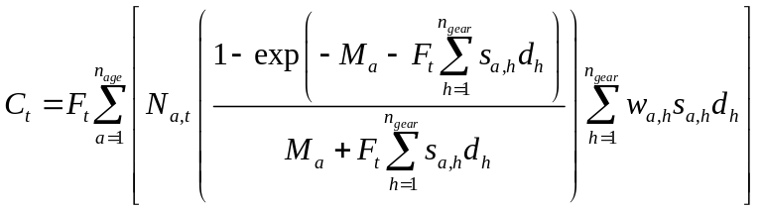

Project numbers-at age for all ages, years, and simulations
For each scenario, a specified number of projection simulations were conducted. The projected numbers at age in each year were based on an annual feedback of “actual” catch if required. The steps for these projections were (for a given species) were as follows:
1) Initialize the simulation index:
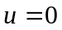
2) Increment the simulation index:
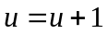
3) Initialize the time index:
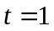
4) Compute numbers at age for initial year of simulation u:
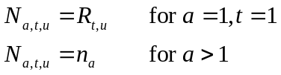
5) Set fishing mortality rate for year t' of simulation u:
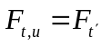
6) Increment time index:
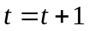
7) Compute numbers at age in year t of simulation u:
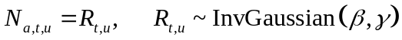 for a=1,
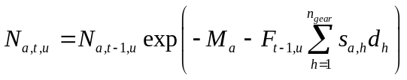 for 1< a < n_{age},
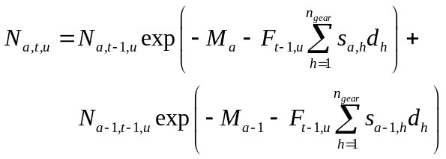 for a = n_{age,}.

9) Compute the ABC fishing mortality rate that establishes the TAC for year t of simulation u. The appropriate fishing mortality rate was determined by the projection year and the relative spawning biomass of the stock as shown in the table below (B_{ref} corresponds to B_{40%} in all cases unless otherwise specified). F_{ref} corresponds to the fishing mortality specified as the F_{ABC} value.
Relative spawning biomass | Fishing mortality rate
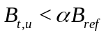 | 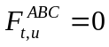
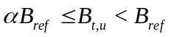 | 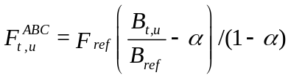
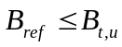 | 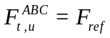
where 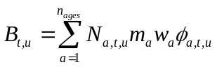 and 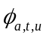 is the total mortality rate between the beginning of the year and the time of spawning. The value of 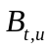 was computed iteratively (since it can be a function of fishing mortality). Note also that for some alternatives (described below) these rules change for some species. For a given Alternative i, the fishing mortality is treated as a function of the F_{ABC} value:
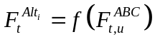 as specified by the alternative.
10) Compute the TAC value as the annually varying limit on catch. For a given species and value of 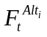(for alternative i) the projection model computes the TAC used in the constraint as
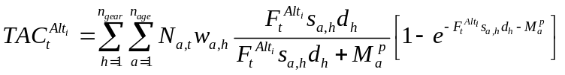.
11) Compute the actual catch, 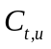, if specified by a TAC model or initial projection year.
12) Solve for the fishing mortality rate 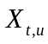 that would set catch equal to in year t of simulation u (as estimated from the multispecies management constrained optimization problem described below and varies by alternative) by solving the following implicit equation:
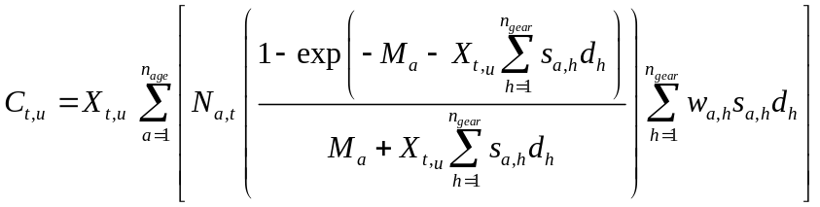

13) Check to see if all years of simulation u have been completed, then continue as necessary:
If t<n_{pro}+1, return to (6)
If t=n_{pro}+1, end simulation u.
14) Return to (2) until all simulations are complete.

Step 5: Store stock performance statistics from the above projections
A series of individual stock performance indicators (for species with age-structure results specified) were computed separately for each alternative and described as follows.
Total biomass in each year and simulation:
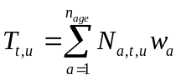
Spawning biomass and catch (as specified above) were stored for each species, year and simulation. Approximate confidence bounds were computed from the simulation output by simply ranking results from the simulations and computing the percentile values corresponding to the desired intervals (here taken as the 10th and 90th percentile). Also computed was the implied spawning biomass per-recruit (SPR) rate given the level of catch in a single year and simulation. For example, the theoretical percentage of unfished spawning output expected from a single recruit if fishing mortality were equal to the estimated fishing mortality over the life of the species.
Average age for each stock in the final projection year across all simulations was also computed as:
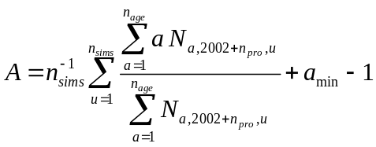

Glossary of symbols used in description of the model

Dimensions
a_{max} Maximum age used in the model (plus group)
a_{min} Minimum age used in the model
n_{age} Number of ages in the model
n_{gear} Number of gear types for which separate selectivity schedules are used (as in the assessments)
n_{pro} Number of years to project beyond the initial year in each simulation
n_{sims} Number of simulations
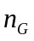 Number of gears with allocation constraints
n_{Fsh} Number of fisheries
n_{sp} Number of species
n_{area} Number of management areas defined for each species

Indices
a Relative age index, 1an_{age}
g Fishery index, 1gn_{Fsh}
k Sub-area
h Fishing gear type
t Projection year index, 1tn_{pro}
t' Projection year index, 1t'number of projection years where catch is pre-specified
u Simulation index, 1un_{sims}
i Alternative index
j Species index

Life History and Fishery Parameters
d_{h} Proportion of total instantaneous fishing mortality rate distributed to gear h
M_{a} Natural mortality rate at age a
m_{a} Proportion of age a fish that are mature
w_{a} Weight-at-age in the population
p Proportion of females in the population
s_{a,h} Selectivity of gear type h for fish of age a (scaled so that max(s)=1)
w_{a,h} Weight of age a fish as sampled by gear h

Other Parameters and Expressions Used in Projections
SPR Spawning biomass per recruit
ABC Acceptable biological catch
TAC Total allowable catch
B_{ref} A parameter of the control rules used to set the overfishing rate and to constrain F_{ABC}
B_{t,u} Spawning biomass in projection year t of simulation u
C_{t,u} Catch in projection year t of simulation u for each population
F_{t,u} Fishing mortality rate in projection year t of simulation u for each population
F_{lim} A parameter of the control rule used to set the overfishing rate
F_{ref} A parameter of the control rule used to constrain F_{ABC}
Fishing mortality rate in projection year t of simulation u for each population
Total mortality rate between the beginning of the year and the spawning period
N_{a,t} Numbers at age a in projection year t
N_{a,t,u} Numbers at age a in projection year t of simulation u
n_{a} Numbers at age a in initial year
O_{t,u} Rate of fishing mortality that constitutes overfishing in projection year t of simulation u
P Probability of overfishing in at least one year of the projection period
R_{t,u} Recruitment in projection year t of simulation u
T_{t,u} Total biomass (between ages a_{min} and a_{max}) in projection year t of simulation u
TAC_{t} TAC actually specified for t
A Average age for each stock in the final projection year across all simulations

Computation of SPR values
Using species specific demographic values, fishing mortality rates (e.g., 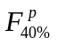) that would reduce the female spawning stock (per recruit) to some fraction of the unfished level. The age-specific factors are: selectivity, natural mortality, maturity, and weight or fecundity. For example, to compute an algorithm to solve the following set of implicit equations was used:
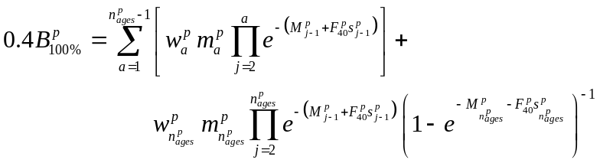
where 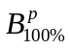 corresponds to the spawning stock per recruit of population p in an unfished equilibrium state. This information was used within the management rule that determines the quota. For some species and alternatives different F-spr rates were used.

Appendix—code for fitting TAC given historical ABC levels
DATA_SECTION
int nsd
!! nsd=5;
init_int nnodes
init_number samplesize
init_number pen_spp
init_number pen_nodes
init_int nspp
init_int nyrs
int nobs
!! nobs = nspp*nyrs*nspp;
init_matrix data(1,nobs,1,5)
3darray obs_tac(1,nyrs,1,nspp,1,nspp)
3darray obs_abc(1,nyrs,1,nspp,1,nspp)
3darray rescaled_abc(1,nyrs,1,nspp,1,nspp)
vector maxabc(1,nspp)
number offset;
imatrix inode(1,nyrs,1,nspp)
LOCAL_CALCS
maxabc.initialize();
for (int i=1;i<=nobs;i++)
{
// TAC_Spp ABC_Spp Yr ABC TAC
obs_abc(data(i,3),data(i,1),data(i,2)) = data(i,4);
obs_tac(data(i,3),data(i,2),data(i,1)) = data(i,5);
if (obs_abc(data(i,3),data(i,1),data(i,2)) > maxabc(data(i,2)))
maxabc(data(i,2)) = obs_abc(data(i,3),data(i,1),data(i,2)) ;
}
int ijunk;
offset = 0.;
for (int i=1;i<=nyrs;i++)
{
for (int j=1;j<=nspp;j++)
{
for (int k=1;k<=nspp;k++)
rescaled_abc(i,j,k) = obs_abc(i,j,k)/maxabc(k);

for (int k=1;k<=nspp;k++)
{
ijunk = int(rescaled_abc(i,j,k)*nnodes) ;
inode(i,k) = ijunk;
}
obs_tac(i,j) /= sum(obs_tac(i,j));
}
offset -= samplesize * obs_tac(i,1) * log(obs_tac(i,1));
}
END_CALCS

PARAMETER_SECTION
number tac_pen;
init_bounded_matrix theta(0,nnodes,1,nspp,-8,8,1)
matrix pred_tac(1,nyrs,1,nspp)
matrix abc_tac(1,nyrs,1,nspp)
sdreport_matrix sdTAC(1,nsd,1,nspp)
vector like(1,4);
objective_function_value obj_fun

PROCEDURE_SECTION
like.initialize();
pred_tac.initialize();
tac_pen=0.0;
for (int i=1;i<=nyrs;i++) {
for (int j=1;j<=nspp;j++) {
pred_tac(i,j) += rescaled_abc(i,1,j) * mfexp(theta(inode(i,j),j)) ;
}
pred_tac(i) /= sum(pred_tac(i));
}
int ijunk;
for (int i=1;i<=nsd;i++) {
for (int j=1;j<=nspp;j++) {
ijunk = int( double(i)/nsd * nnodes) ;
sdTAC(i,j) = double(i)/double(nsd) * mfexp( theta(ijunk,j) ) ;
}
}
// Fit the TAC portions
for (int i=1;i<=nyrs;i++)
like(1) -= samplesize * obs_tac(i,1) * log(pred_tac(i)) ;
like(1) -= offset;

// Penalize differences in theta over species...
for (int i=0;i<=nnodes;i++)
like(2) += pen_spp * norm2(first_difference(first_difference(theta(i))));

// Penalize differences in theta over nodes...
if (nnodes >1)
for (int j=1;j<=nspp;j++)
like(3) += pen_nodes*norm2(first_difference(first_difference(trans(theta)(j))));

// Penalize TAC less than ABC's...
dvariable xtmp;
for (int i=1;i<=nyrs;i++)
{
for (int j=1;j<=nspp;j++)
{
abc_tac(i,j) = obs_abc(i,1,j)-(2.0*pred_tac(i,j));
xtmp = posfun( (abc_tac(i,j) ), 0.2 , tac_pen );
}
}
like(4) = 20.*tac_pen;
obj_fun = sum(like);

REPORT_SECTION
report<<"Obs_TAC " <<endl;
for (int i=1;i<=nyrs;i++)
report<<2.*obs_tac(i,1)<< " Pred: "<<i<<" "<<2.*pred_tac(i)<<endl;
report<<"Pred_TAC " <<endl;
for (int i=1;i<=nyrs;i++)
report<<2.*pred_tac(i)<<endl;
report<<"Obs_ABC " <<endl;
for (int i=1;i<=nyrs;i++)
report<<rescaled_abc(i,1)<<endl;
report<<"Obs_ABC/Pred_TAC " <<endl;
for (int i=1;i<=nyrs;i++)
report<<abc_tac(i)<<endl;
report<<"#_Nodes,_samsize,_penaltyspp,_pennode,_Likelihoods"<<endl;
report<<nnodes<<" "<<samplesize<<" "<<pen_spp<<" "<<pen_nodes<<" "<<like<<endl;
report<<"TAC_by_nodes"<<endl;
for (int i=1;i<=nsd;i++) report<<sdTAC(i)<<endl;
ofstream ofs("tacpar.dat");
ofs << nspp <<endl;
ofs << nnodes <<endl;
ofs << maxabc <<endl;
ofs << theta <<endl;
ofs.close();
TOP_OF_MAIN_SECTION
gradient_structure::set_MAX_NVAR_OFFSET(1600);
gradient_structure::set_GRADSTACK_BUFFER_SIZE(200000);
gradient_structure::set_NUM_DEPENDENT_VARIABLES(800);
gradient_structure::set_CMPDIF_BUFFER_SIZE(2000000);

Note that new options to follow conditioned or estimated stock-recruitment relationships are added as options. These include Ricker or Beverton-Holt forms with log-normal variability and are detailed as options a)-d) above.

